**SEO Project: Personal Portfolio Website**

**Part 1: Analysis**

**1. Research and choose several keywords for your personal web page. Explain why you chose the ones you did.**

Most common key word in our field is the ‘Web Developer’ .As it sounds like the most common used word in the SEO. You can easily put your website on top if you have enough looks and feature. This keyword is helps to put your website in the list of other competitors as you can see there are number of web developer in the world .This is the main reason to choose this word as the key word.

Other one is Engineering. As we all can see that we have lots of engineer and it’s easy to search this word in SEO plan. This is good thing to make it as your keyword.

Developer is also considering as the key word because this word is most common in our field. This word is a field name that s searched by any company or any employee. Developer is the most important part of the IT field.

HTML, JAVA, ASP.NET, CSS etc are those languages which is most famous and most basic language. They are like basic need of any web site and you have to accept it that without it you cannot make any web site.

The framework is also a key word because as you know this is one element in our field that has been normally used by designer. So, this can be also put in SEO side.

Database is also the key word for us. That can also you can put in SEO.

Dancing and singing also is a type of key word as you see these are common habits in any human and also when someone search about that your website is shown over there.

2. **Design the basic structure of your website and create an XML sitemap.**

<?xml version="1.0" encoding="UTF-8" ?>

<urlset xmlns="**http://www.sitemaps.org/schemas/sitemap/0.9**" xmlns:xsi="**http://www.w3.org/2001/XMLSchema-instance**" xsi:schemaLocation="**http://www.sitemaps.org/schemas/sitemap/0.9 http://www.sitemaps.org/schemas/sitemap/0.9/sitemap.xsd**">

- <!--

created with Free Online Sitemap Generator www.xml-sitemaps.com

-->

<url>

<loc>**https://binalpatel15.github.io/BinalPatel_WT/**</loc>

<lastmod>**2019-12-12T00:45:29+00:00**</lastmod>

<priority>**1.00**</priority>

</url>

<url>

<loc>**https://binalpatel15.github.io/BinalPatel_WT/index.html**</loc>

<lastmod>**2019-12-12T00:45:29+00:00**</lastmod>

<priority>**0.80**</priority>

</url>

<url>

<loc>**https://binalpatel15.github.io/BinalPatel_WT/myresume.pdf**</loc>

<lastmod>**2019-12-12T00:45:29+00:00**</lastmod>

<priority>**0.80**</priority>

</url>

<url>

<loc>**https://binalpatel15.github.io/BinalPatel_WT/mysite/index.html**</loc>

<lastmod>**2019-12-12T00:45:29+00:00**</lastmod>

<priority>**0.80**</priority>

</url>

</urlset>

3. **Search for local competitors, try to find individual people, not a company.**

* **Blake Stiller**

He is programming designer and professor with over 5 years of experience in engineering, plan, advancement and support of enormous, crucial applications, essential in vitality, media transmission and human services divisions.

He is online learning designer, Web development professor, technician and web designer.

* **Cryo Dragon**

Cryo dragon has 15 years of experience composing web applications that length shopper efficiency programming to strategic budgetary exchanging stages. He has broad information on front-end JavaScript and program APIs just as huge involvement in well known systems and libraries like React and Redux. His profound full-stack experience incorporates Node.js and Express, MongoDB just as increasingly conventional advancements like PHP, ASP.NET, and MySQL

# Alex Leuschner

Sabry has 16 years of expert programming experience, with the keep going nine concentrated on creating sixteen websites including mobile and personal websites. Some of these are fresh local lamb, St. Jacobs Quilt Company, TBT Medical.

Above that, he has experience in networking. He is also built plenty of computer setups and handle problem related software.

4. Use tools like openlinkprofiler to find the backlinks for your competitors.

Blake Stiller

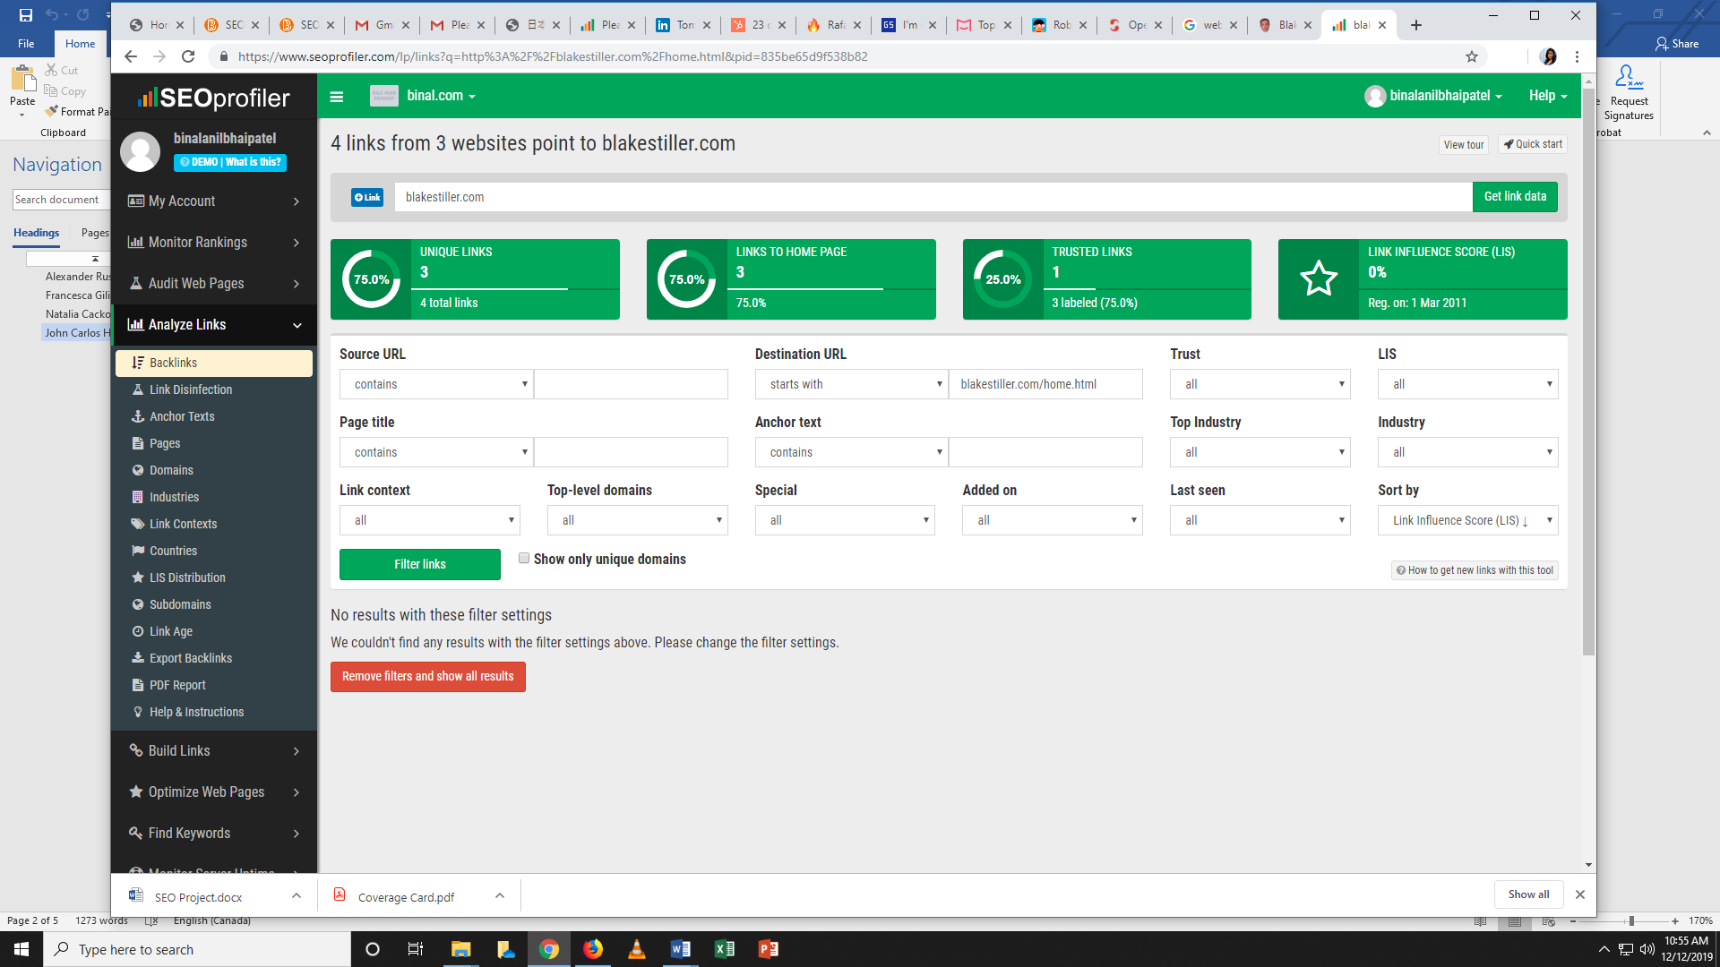

2. Cryo Dragon

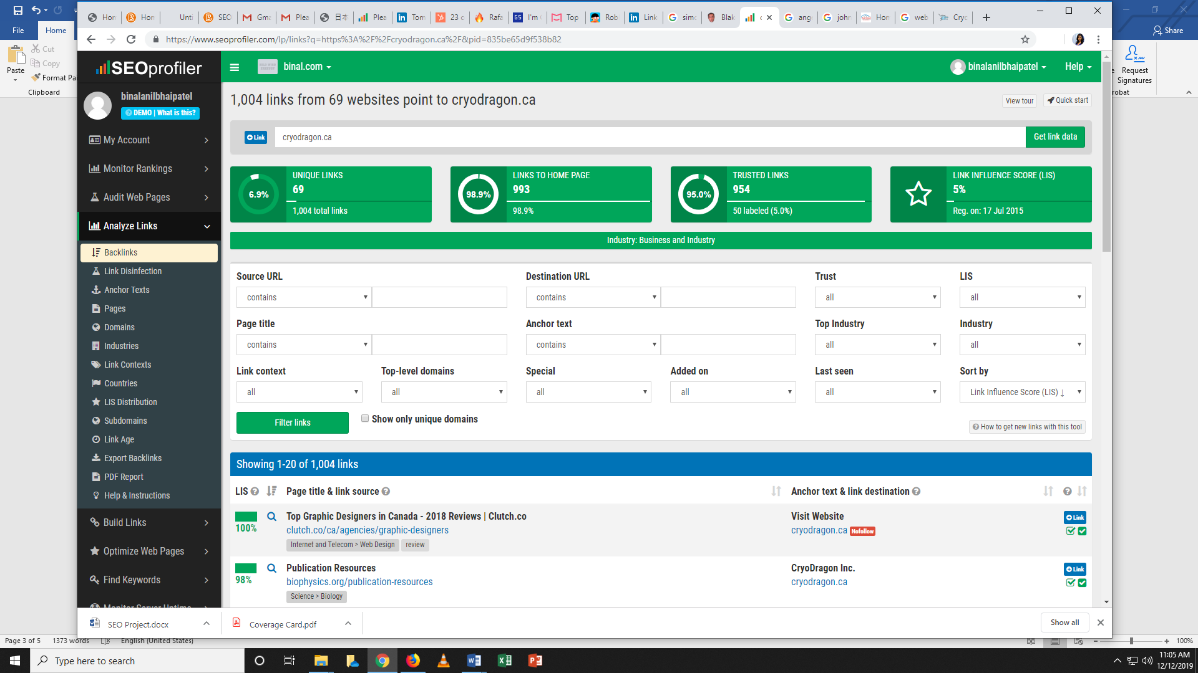

# 3. Alex Leuschner

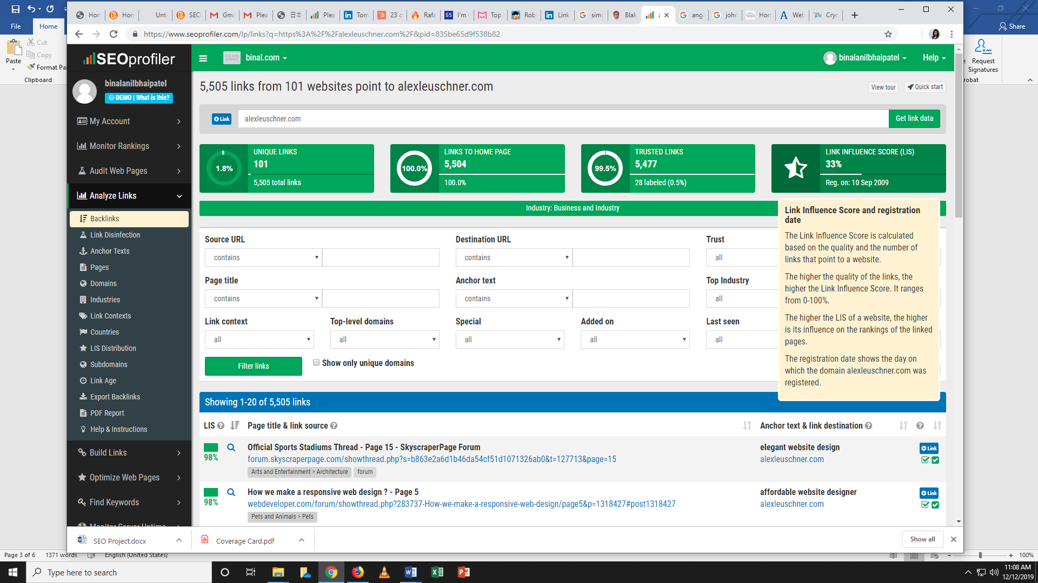

**5. Create a brief plan (about 650 words) describing what your SEO strategy would be to improve your ranking for your chosen keywords and how you would deal with your competition. Note: You don’t have to implement the strategy.**

As should be obvious here I am making the layout of my portfolio, I utilized many mew and fundamental and some special words that can be utilized as the watchword in SEO. Website design enhancement has some essential rationale like as I am utilizing a few words like Engineering and language and aptitudes an and so on. Those are basic words that can be utilized by any ordinary individuals. That is the explanation that I put that name over yonder with the goal that my site will be appeared in the outcome for any ordinary individuals window.

In my portfolio I use words like aptitudes, Education, Activity. These are not regularly utilized in any site that can be stating that my page has some one of a kind web words that cause me to contrast from other site page. SO in the challenge word I can be lead in contrast with other contender.

In my layout I have Home page, About page, Education page, Skills page, Activities page, a My Work page. These all pages are set as the stream that can assist the watchers with following the basic stream. As you can watch I put everything on one page with the goal that a client don't have to move from one page to different as it is the new and feels so captivating. This is some new slanting that not pursued by each designer. This has some JS execution and new CSS impacts.

I put some social links like Instagram, Facebook, Github, LinkedIn.

These are most regular online life source that can makes you progressively well known and consistently be dynamic. These are most and more close by utilize like each morning a human see proposals everything first than start his/her day, So that makes me feel progressively alluring. And for organization and businesses are likewise no utilization to see every single social sire since they get every one of the subtleties of any worker effectively from that point.

In about me part, I speak to myself extremely basic and good way, The things I love to do and the exercises that I for the most part do in my relaxation time. I put my instruction and my side interests. These words are a piece of SEO as well, so makes my about part progressively appealing and quick in search. I demonstrate my age just as my conceived spot that is likewise help to place in the lost of SEO. About is about me so when any reader read your that blog they can without much of a stretch envision your picture in their mind and make a positive picture.

In my education part I give the name of my college and the duration. That can help the company to know more about my background as well as they also put me in the queue of that similar college and then compare with others. That also helps in SEO concept as well as this information are trustworthy.

In my abilities, I put my instruction side intrigue like the language I utilized, database, structure, a few devices and so on. This part has generally normal and specialized catchphrases like JAVA, CSS, mySQL, Bootstrap and so forth. These all are helps in SEO methodology just as this is the most significant data for any IT organization that why that contract you, since that shows your adaptability with all dialects and instruments. In others I notice my capacity like the supervisory crew and initiative, specialized composition. Propositions all are ideal to contend with other contender and in SEO.

In my Activity part I put some my additional exercises like I partook in occasion of my school and some specialized fest just as some social occasion as well. That likewise lead me contrast with others since that additionally be the piece of our portfolio and not every person put that in their site.

In my work, I put one of my simple website that has been made by me and also some screen shots too.

My portfolio has basic keywords that can be helps in SEO concept and the design is simple and decent that any third party can understand easily One page configuration is most agreeable plan being developed period.

<http://binalpatel.000webhostapp.com/>